Certificate of Course Completion
Preventive Health and Safety for Child Care Providers

This certificate verifies that

(First and Last name)

has completed all 8 hours of the Preventive Health and Safety for Child Care Providers course, using curriculum and materials approved by the California Emergency Medical Services Authority, under the direction of the UCSF-California Childcare Health Program Preventive Health Training Program. The course includes 1 hour of nutrition and instruction in the prevention of lead exposure, as required by California Health and Safety Code Section 1596.866.

Course Completion Date:
Month/Day/Year

Instructor’s Name:

Instructor’s Signature:

Instructor’s Affiliate Program:
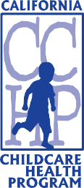
Affix the Course Completion Sticker in this box

[Delete this text box and paste your organization’s logo here]

